**Title of work: Sales Lab**

**Name :** Shani Patel

**Student number :**

**Section Code:** NEE

**Date submitted:** 14/07/2021

**Professor's name:** Tevin Apenteng

1. Create a class diagram to support the above case study and Systems Use Case Specifications

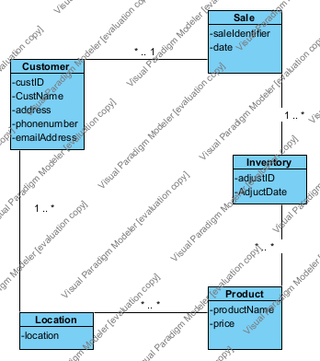

1. Create an object level sequence diagram, detailing the Create Customer systems use case specification

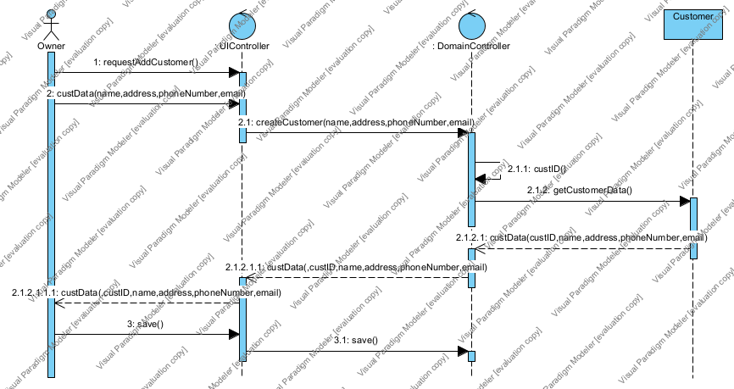

1. Create an object level sequence diagram, detailing the Create Sales use case specification

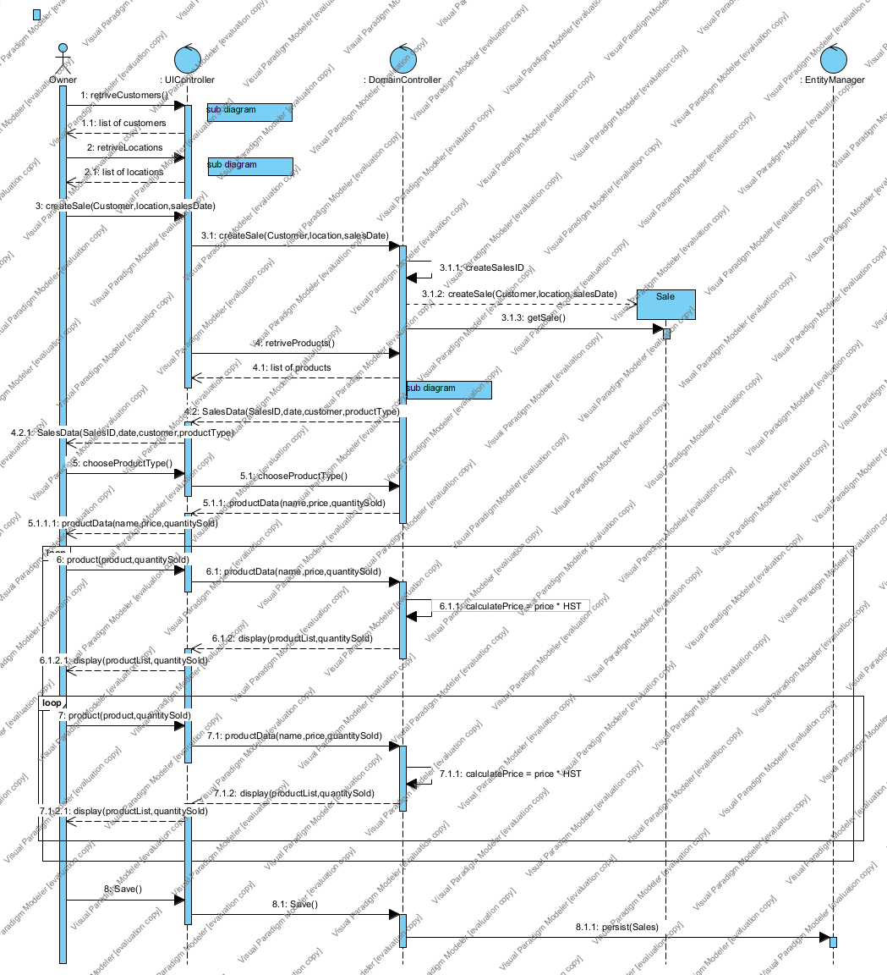

retriveCustomers

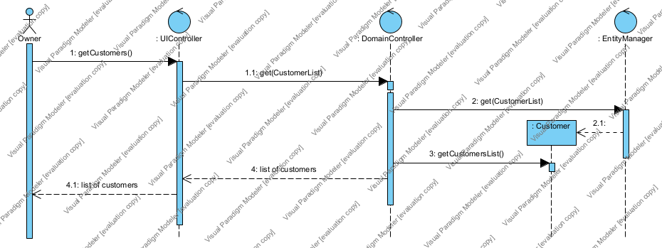

retriveLocations

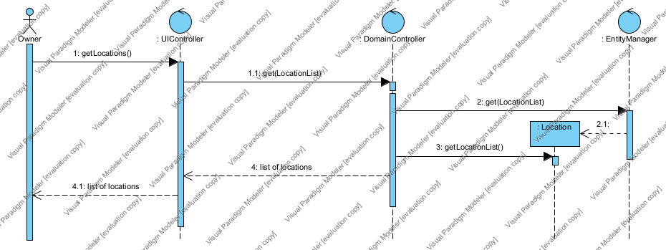

retriveProducts

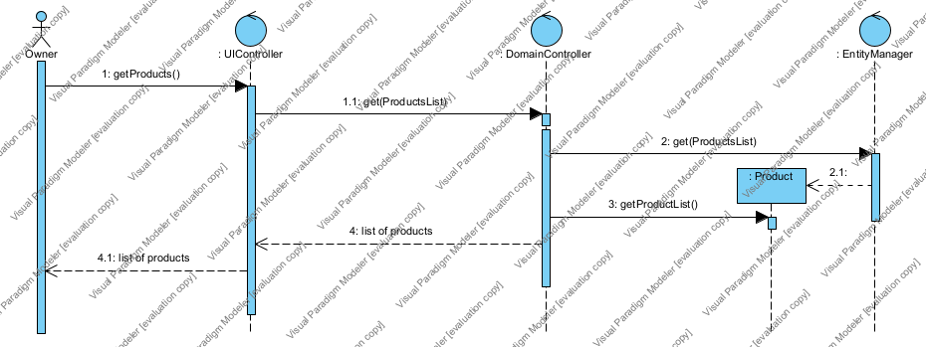

1. Create an object level sequence diagram, detailing the Query Sales system use case specification.

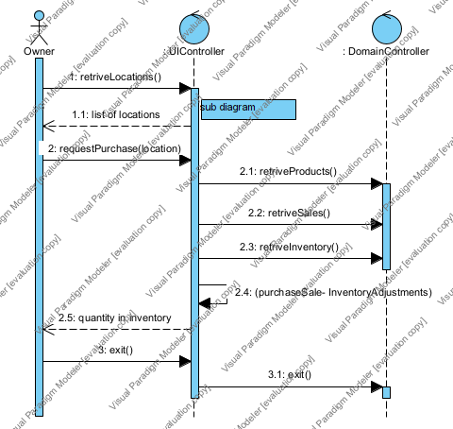

retriveLocations



1. Create an object level sequence diagram, detailing the Create Inventory Adjustment system use case specification.

